Sometimes, I feel the burden Lord Shiva has to carry. All negativity converges into Him, all vices ends in Him. He's the only antipole to every positive source out there, the suns, the rains, the enlightened ones, the naive hearts, the true, and everything that ensues.

There, while others were discussing how to part with the elixir, He was worried for the poison. Why would He be revered and feared at the same time? Why would he become the destroyer? Because an honest man knows pain, and truth.

[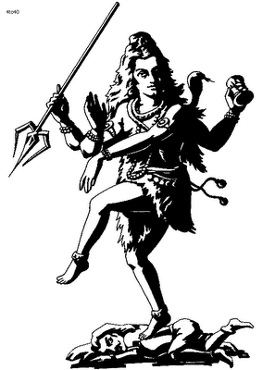](http://4.bp.blogspot.com/-Vo9Qp7lQapo/UBTgTjU7PRI/AAAAAAAAGM0/nmAFypf2ONc/s1600/Nataraj_The_Dancing_Shiva.gif)

The poison, of words, of ill feelings, of hatred, of misdeeds, of unbecoming acts, of farces and facades, He drank it all, and did not break still. How does one kill someone who conquers death and becomes the Mahamrityunjay? One doesn't. And how many times must He have died at your hands and deeds? Ever thought of that?

He's there, clean of all of it, and yet terminates it. He's like the ocean, where everything pure and impure ends, but does not alter the sanity of the ocean, the one we call His trance. It is in those moments of pride, that I've wished to bear him in me, and listen, and give hope to anyone who needs it. But oh, what a great burden it is, to bear it all and have no one to tell of it, share it, and see weight lifted. Who'd be there when He'd need it? I've often burned bridges when I bulged and seethed under burden, and have wished for companionship. And then, I feel how heavy His heart would have been had Ma Parvati not been there.

It is in those dark moments that I see how lucky my Master is, to have Her, and it is in those moments that I understand the sorrow of the Neelkanth when Sati was taken away from him. Sati, his love of life, what did her family do to him? Snatched her away. Destroy one's world and assume that our world is safe? That is foolishness.

He has known too much, he chose silence. He smile at us and lift us up like a father. He’d relieve us of our misery all the time, every single time when we falter. He won’t kill us, he’s a father. He’ll do the last rites for us, when we're dead already. He knows too much, he won’t speak of it. He’d lose himself to tranceful state of Bhaang and watch it all. He’ll take the blame, we would die clean. He's God, like every father.

Master, I admire you, I love you for the arduous task You've taken on Your mighty shoulders. I'd just want to mend one person to reduce this burden of yours.

[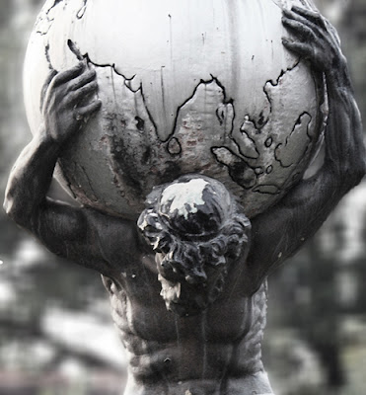](http://4.bp.blogspot.com/-4Q3Up5nQcsc/UBTgFqx5hGI/AAAAAAAAGMs/jZ0yh9cEmZk/s1600/4263863504_70a882121a.jpg)

Myself!